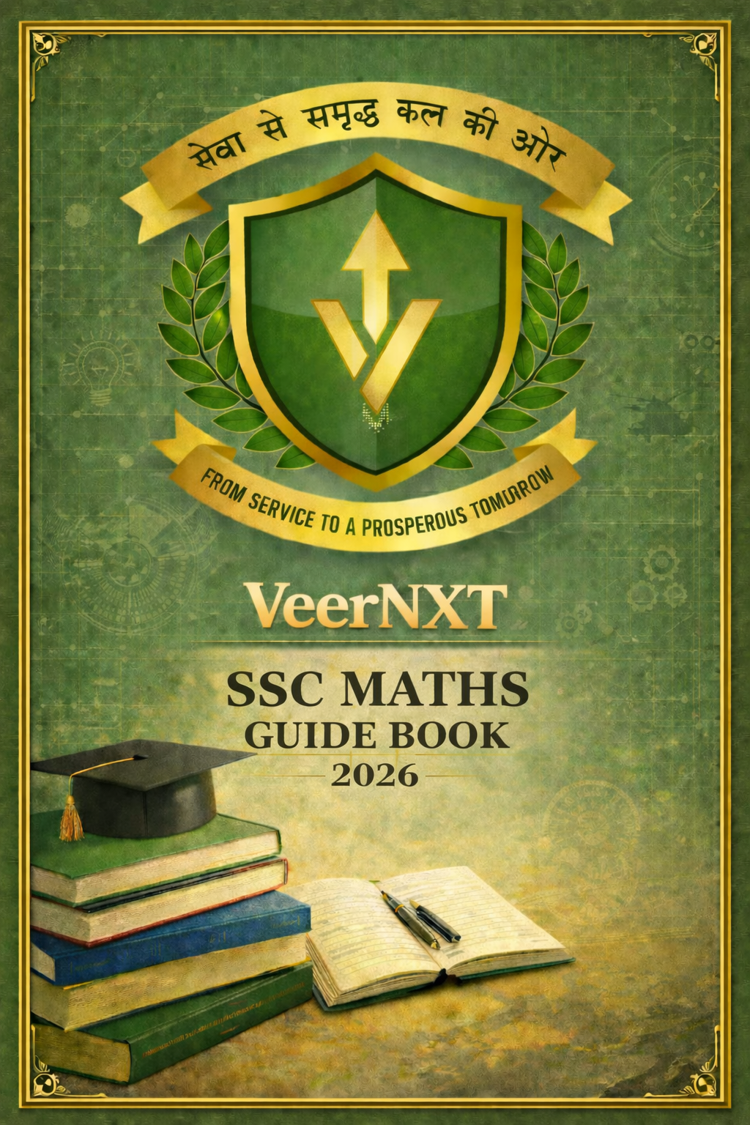
CONTENTS

MATHS GUIDE BOOK 3
PART 1 3
PART 2 4
PART 4 6
PART 5 8
PART 8 10
PART 9 12
PART 10 14
REASONING GUIDE BOOK 17
PART 1 – BASIC REASONING 17
PART 2 – ANALYTICAL REASONING 19
PART 3 – BLOOD RELATION, DIRECTION & VENN 21
PART 4 – SERIES & MISCELLANEOUS 24
PART 5 – NON VERBAL & MIXED PRACTICE 26

MATHS GUIDE BOOK

PART 1
NUMBER SYSTEM

1. NUMBER SYSTEM – BASIC CONCEPT
Number System deals with classification and properties of numbers used in calculations.
In SSC examination, questions from Number System are:
• Basic
• Concept-based
• Usually one or two steps only

Types of Numbers
Type | Explanation
Natural Numbers | 1, 2, 3, 4, …
Whole Numbers | 0, 1, 2, 3, …
Integers | …, –3, –2, –1, 0, 1, 2, 3 …
Rational Numbers | Numbers expressible as p/q
Irrational Numbers | Numbers not expressible as p/q (√2, π)
Prime Numbers | Numbers divisible only by 1 and itself
Composite Numbers | Numbers having more than two factors

2. IMPORTANT PROPERTIES (VERY IMPORTANT FOR SSC)
Even and Odd Numbers:
• Even + Even = Even
• Odd + Odd = Even
• Even + Odd = Odd
• Even × Odd = Even
• Odd × Odd = Odd
Prime Numbers:
• 2 is the only even prime number
• 1 is neither prime nor composite
• Every composite number can be expressed as a product of prime numbers

3. DIVISIBILITY RULES (FREQUENTLY ASKED)
Number | Rule
2 | Last digit must be even
3 | Sum of digits divisible by 3
4 | Last two digits divisible by 4
5 | Last digit is 0 or 5
6 | Divisible by both 2 and 3
9 | Sum of digits divisible by 9
11 | Difference of alternate digit sums is 0 or multiple of 11

4. FACTORS & MULTIPLES
Factor: A number that divides another number exactly.
Multiple: The result obtained after multiplication.
Important Points:
• Smallest factor of any number is 1
• Largest factor of any number is the number itself

5. SOLVED EXAMPLES
Example 1:
Which of the following is a prime number?
A. 21 B. 29 C. 39 D. 51
Answer: 29
Example 2:
What is the unit digit of 7⁴?
7¹ = 7
7² = 49
7³ = 343
7⁴ = 2401
Answer: 1

6. PRACTICE QUESTIONS
Q1. Which of the following is not a composite number?
A. 1 B. 4 C. 6 D. 9
Q2. Find the number of factors of 16.
A. 4 B. 5 C. 6 D. 7
Q3. Which number is divisible by 11?
A. 121 B. 132 C. 143 D. 154

ANSWER KEY
Q1. A
Q2. B
Q3. A

PART 2
LCM & HCF

1. BASIC CONCEPT
- HCF (Highest Common Factor):
- HCF of two or more numbers is the greatest number that divides each of them exactly.
- LCM (Least Common Multiple):
- LCM of two or more numbers is the smallest number which is exactly divisible by each of them.
In SSC examination, questions from LCM & HCF are:
• Direct
• Formula-based
• Application-oriented (word problems)

METHODS TO FIND HCF & LCM

(A) PRIME FACTORISATION METHOD
Steps:
1. Resolve each number into prime factors.
2. For HCF, take common prime factors with the lowest power.
3. For LCM, take all prime factors with the highest power.
Example:
1)Find HCF and LCM of 12 and 18.
12 = 2² × 3
18 = 2 × 3²
HCF = 2 × 3 = 6
LCM = 2² × 3² = 36

(B) DIVISION METHOD
Steps:
1. Divide the numbers by the smallest possible prime number.
2. Continue dividing till no further division is possible.
3. Product of the divisors gives the HCF.
4. Product of the divisors and remaining numbers gives the LCM.

3. IMPORTANT RELATION BETWEEN HCF & LCM
- For two numbers:
HCF × LCM = Product of the two numbers
Example:
1)If HCF = 6 and LCM = 180, and one number is 30, find the other.
6 × 180 = 30 × x
x = 36
Numbers are 30 and 36.

4. HCF & LCM OF FRACTIONS
- HCF of fractions:
HCF = (HCF of numerators) / (LCM of denominators)
- LCM of fractions:
LCM = (LCM of numerators) / (HCF of denominators)

Example:
1)Find HCF and LCM of 2/3 and 4/9.
HCF = 2 / 9
LCM = 4 / 3

5. WORD PROBLEMS
Example 1:
Two numbers have HCF = 12 and LCM = 180. If one number is 36, find the other.
Solution:
12 × 180 = 36 × x
x = 60

Example 2:
A bell rings every 6 minutes and another every 8 minutes. After how much time will they ring together?
Solution:
LCM of 6 and 8 = 24 minutes

6. IMPORTANT POINTS TO REMEMBER
• HCF of two co-prime numbers is 1.
• LCM of two co-prime numbers is their product.
• HCF always divides LCM.
• LCM is always greater than or equal to the greatest number.

7. SOLVED EXAMPLE
Example 1:
Find the HCF of 24 and 36.
HCF = 12
Example 2:
Find the LCM of 15 and 20.
LCM = 60

8. PRACTICE QUESTIONS
Q1. Find the HCF of 18 and 42.
A. 6 B. 12 C. 18 D. 21
Q2. Find the LCM of 12, 15 and 20.
A. 60 B. 120 C. 180 D. 240
Q3. The HCF and LCM of two numbers are 8 and 96. If one number is 24, find the other.
A. 32 B. 36 C. 48 D. 64

ANSWER KEY
Q1. A
Q2. B
Q3. A

PART 4
RATIO & PROPORTION

1. BASIC CONCEPT
Ratio:
- A ratio is a comparison of two quantities of the same kind.
- Ratio of a and b = a : b
Example:
Ratio of 10 and 20 = 10 : 20 = 1 : 2
Proportion:
- When two ratios are equal, they form a proportion.
- a : b = c : d
This can also be written as:
a × d = b × c
- In SSC examination, questions from this topic are:
• Direct
• Formula-based
• Mostly numerical

2. IMPORTANT PROPERTIES OF RATIO
• Ratio has no unit.
• Both terms must be of the same unit.
• Ratio can be simplified like fractions.
• Ratio remains same if both terms are multiplied or divided by the same number.

3. TYPES OF RATIO QUESTIONS

(A) SIMPLE RATIO QUESTIONS
Example 1:
Find the ratio of 45 minutes to 1.5 hours.
Solution:
1.5 hours = 90 minutes
45 : 90 = 1 : 2
Answer: 1 : 2

(B) RATIO IN FRACTIONS
Example 2:
Find the ratio of 3/4 and 5/6.
Solution:
(3/4) : (5/6) = (3/4) × (6/5) = 18/20 = 9 : 10
Answer: 9 : 10

4. PROPORTION BASED QUESTIONS
If a : b = c : d, then:
a × d = b × c
Example 3:
If 4 : 7 = x : 28, find x.
Solution:
4 × 28 = 7 × x
x = 16
Answer: 16

5. COMPOUND RATIO
Compound ratio is the ratio obtained by multiplying corresponding terms of two or more ratios.
Example 4:
Find the compound ratio of 2 : 3 and 4 : 5.
Solution:
(2 × 4) : (3 × 5) = 8 : 15
Answer: 8 : 15

6. RATIO IN DISTRIBUTION PROBLEMS
Example 5:
Divide ₹600 between A and B in the ratio 2 : 3.
Solution:
Total parts = 2 + 3 = 5
A’s share = (2/5) × 600 = 240
B’s share = (3/5) × 600 = 360
Answer: A = ₹240, B = ₹360

7. IMPORTANT POINTS TO REMEMBER
• Convert all quantities to the same unit.
• Simplify ratios to lowest form.
• Use proportion formula carefully.
• Ratio questions are often combined with percentage.

8. SOLVED EXAMPLES
Example 6:
The ratio of boys to girls in a class is 3 : 2. If there are 30 boys, find the number of girls.
Solution:
3 : 2 = 30 : x
x = 20
Answer: 20
Example 7:
If a : b = 5 : 7 and b : c = 14 : 15, find a : c.
Solution:
a : b = 10 : 14
b : c = 14 : 15
a : c = 10 : 15 = 2 : 3
Answer: 2 : 3

9. PRACTICE QUESTIONS
Q1. Find the ratio of 500 g to 2 kg.
A. 1 : 4 B. 1 : 2 C. 1 : 3 D. 1 : 5
Q2. If x : y = 7 : 9 and y : z = 3 : 5, find x : z.
A. 7 : 15 B. 21 : 45 C. 21 : 35 D. 35 : 45
Q3. Divide ₹840 between A and B in the ratio 4 : 3.
A. ₹480, ₹360 B. ₹420, ₹420 C. ₹360, ₹480 D. ₹560, ₹280

ANSWER KEY
Q1. B
Q2. C
Q3. A

PART 5
PERCENTAGE

1. BASIC CONCEPT
- Percentage means 'per hundred'.
1% = 1/100
- Percentage is used to express increase or decrease, comparison, profit and loss, marks, population, growth, etc.
In SSC examination, percentage questions are direct, formula-based, and often linked with Ratio, Profit–Loss and Simple Interest.

2. CONVERSION RULES
- Fraction to Percentage:
(a/b) × 100
Example: 3/5 = 60%

- Percentage to Fraction:
x% = x/100
Example: 25% = 1/4

- Decimal to Percentage:
Multiply the decimal by 100
Example: 0.75 = 75%

3. IMPORTANT PERCENTAGE VALUES
Fraction | Percentage
1/2 | 50%
1/3 | 33⅓%
1/4 | 25%
1/5 | 20%
1/8 | 12.5%
3/4 | 75%

4. PERCENTAGE INCREASE & DECREASE
- Increase Percentage:
(Increase / Original) × 100
- Decrease Percentage:
(Decrease / Original) × 100
- Example:
Price increases from ₹200 to ₹250.
Increase = 50
(50/200) × 100 = 25%
Increase = 25%

5. SUCCESSIVE PERCENTAGE CHANGE
When two percentage changes occur successively:
- Net % = a + b + (ab/100)
- Use negative sign for decrease.
Example:
Increase by 10% and then decrease by 10%.
Net = 10 – 10 – (100/100)
Net decrease = 1%

6. PERCENTAGE OF A QUANTITY
Formula:
- x% of y = (x/100) × y
Example:
15% of 400 = (15/100) × 400 = 60

7. REVERSE PERCENTAGE
Example:
If 20% of a number is 50, find the number.
(20/100) × x = 50
x = 250

8. SOLVED EXAMPLES
Example 1:
A student scored 360 marks out of 450. Find the percentage.
(360/450) × 100 = 80%
Example 2:
Population of a town is 40,000. It increases by 5%.
Increase = 2,000
New population = 42,000

9. PRACTICE QUESTIONS
Q1. What is 25% of 640?
A. 120 B. 140 C. 160 D. 180
Q2. Price decreases from ₹500 to ₹450. Find the percentage decrease.
A. 8% B. 9% C. 10% D. 12%
Q3. A number is increased by 20% and then decreased by 10%. Find the net change.
A. 8% increase B. 10% decrease C. No change D. 2% increase

ANSWER KEY
Q1. C
Q2. C
Q3. A

PART 8
AVERAGE

1. BASIC CONCEPT
- Average of a group of numbers is a single value that represents the central value of the group.
- Formula:
Average = (Sum of observations) / (Number of observations)
In SSC examination, questions on average are direct, formula-based, and often linked with age, salary, marks, population and similar topics.

2. AVERAGE OF NUMBERS
- Example:
Find the average of 10, 20, 30, 40 and 50.
- Sum = 150
Number of observations = 5
- Average = 150 / 5 = 30

3. FINDING SUM WHEN AVERAGE IS GIVEN
- Formula:
Sum = Average × Number of observations
- Example:
Average age of 10 students is 18 years.
Total age = 18 × 10 = 180 years

4. AVERAGE WHEN A VALUE IS ADDED OR REMOVED
Example 1:
Average of 5 numbers is 20. A new number 30 is added.
Old sum = 20 × 5 = 100
New sum = 100 + 30 = 130
New number of observations = 6
New average = 130 / 6 ≈ 21.67
Example 2:
Average of 10 numbers is 25. One number 35 is removed.
Old sum = 25 × 10 = 250
New sum = 250 − 35 = 215
New number of observations = 9
New average = 215 / 9 ≈ 23.89

5. AVERAGE OF AGES
Example:
- Average age of 5 boys is 20 years and average age of 3 girls is 18 years.
- Sum of boys = 5 × 20 = 100
- Sum of girls = 3 × 18 = 54
- Total sum = 154
- Total persons = 8
Average age = 154 / 8 = 19.25 years

6. WEIGHTED AVERAGE
Weighted average is used when groups have different sizes.
Example:
- Average marks of 20 students is 60 and average marks of 30 students is 50.
- Total marks = (20 × 60) + (30 × 50) = 2700
- Total students = 50
Average marks = 2700 / 50 = 54

7. IMPORTANT POINTS TO REMEMBER
• Always calculate total sum first.
• Be careful when values are added or removed.
• Average depends on sum and number of terms.
• SSC questions are generally simple and direct.

8. SOLVED EXAMPLES
Example 1:
Average salary of 15 workers is ₹8000.
Total salary = 8000 × 15 = ₹1,20,000
Example 2:
Average of 6 numbers is 12.
Sum of numbers = 12 × 6 = 72

9. PRACTICE QUESTIONS
Q1. Find the average of first 10 natural numbers.
A. 5 B. 5.5 C. 6 D. 6.5
Q2. Average age of 8 persons is 30 years. What is their total age?
A. 220 B. 230 C. 240 D. 250
Q3. Average of 4 numbers is 25. If one number is 40, find the average of remaining 3 numbers.
A. 18 B. 20 C. 22 D. 25

ANSWER KEY
Q1. B
Q2. C
Q3. B

PART 9
TIME & WORK

1. BASIC CONCEPT
- Time & Work deals with how long a person or group of persons take to complete a work and their efficiency.
In SSC examination, questions are direct, formula-based and mostly one to two step problems.

2. BASIC FORMULAS
- Work = Rate × Time
- If a person can complete a work in x days, then one day’s work = 1/x.

3. SINGLE PERSON WORK
Example 1:
A can complete a work in 10 days.
Work done by A in one day = 1/10
Example 2:
If a person does 1/8 work in one day, then total time = 8 days.

4. TWO PERSONS WORKING TOGETHER
- If A completes work in x days and B in y days, then combined work per day = (1/x + 1/y).
- Total time = 1 / (1/x + 1/y).
Example 3:
A can do a work in 12 days and B in 18 days.
1/12 + 1/18 = 5/36
Time = 36/5 = 7.2 days.

5. WORK AND EFFICIENCY
- Efficiency is inversely proportional to time.
- If efficiency ratio of A : B = x : y, then time ratio = y : x.
Example 4:
A is twice as efficient as B. B takes 20 days.
Time taken by A = 10 days.

6. PARTIAL WORK
Example 5:
A can do a work in 10 days. He works for 4 days.
Work done = 4 × 1/10 = 2/5
Remaining work = 3/5.

7. MEN–DAYS CONCEPT
- Men × Days = Constant
Example 6:
10 men can do a work in 6 days.
15 men will take = 4 days.

8. SOLVED EXAMPLES (SSC LEVEL)
Example 7:
A can do a work in 15 days and B in 20 days.
Time together = 60/7 ≈ 8.57 days.
Example 8:
A alone can do a work in 25 days.
Work done in 5 days = 1/5.

9. IMPORTANT POINTS TO REMEMBER
• Take total work as 1.
• Use fractions for accuracy.
• Efficiency is inversely proportional to time.
• SSC avoids lengthy time–work questions.

10. PRACTICE QUESTIONS
Q1. A can complete a work in 20 days. How much work will he do in 5 days?
A. 1/2 B. 1/4 C. 1/5 D. 1/10
Q2. A and B can do a work in 12 days and 18 days respectively. How long will they take together?
A. 6 days B. 7.2 days C. 8 days D. 9 days
Q3. 12 men can do a work in 10 days. How many days will 15 men take?
A. 6 B. 7 C. 8 D. 9

ANSWER KEY
Q1. C
Q2. B
Q3. C

PART 10
TIME, SPEED & DISTANCE + BASIC MENSURATION + BASIC DATA INTERPRETATION

SECTION A: TIME, SPEED & DISTANCE

1. BASIC CONCEPT
Speed = Distance / Time
Distance = Speed × Time
Time = Distance / Speed
SSC questions from this area are direct and calculation-light.

2. SPEED CONVERSION
1 km/hr = 5/18 m/s
1 m/s = 18/5 km/hr
Example:
36 km/hr = 36 × 5/18 = 10 m/s

3. AVERAGE SPEED
For equal distance:
Average speed = (2xy)/(x+y)
Example:
40 km/hr and 60 km/hr
Average speed = 48 km/hr

4. RELATIVE SPEED
Same direction: Difference of speeds
Opposite direction: Sum of speeds
Example:
50 km/hr and 70 km/hr (opposite)
Relative speed = 120 km/hr

5. TRAIN PROBLEMS
Time to cross an object = Length / Relative speed
Example:
Train length = 100 m, time = 10 s
Speed = 10 m/s

SECTION B: BASIC MENSURATION

6. 2D FIGURES
Square:
Area = a², Perimeter = 4a
Rectangle:
Area = l × b, Perimeter = 2(l+b)
Circle:
Area = πr², Circumference = 2πr
Example:
Radius = 7 cm
Area = 154 cm²

7. 3D FIGURES
Cube:
Volume = a³, TSA = 6a²
Cuboid:
Volume = l × b × h
Cylinder:
Volume = πr²h
Example:
Cube side = 5 cm
Volume = 125 cm³

SECTION C: BASIC DATA INTERPRETATION

8. DATA INTERPRETATION
SSC DI questions are simple and based on totals and averages.
Subject | Marks
Maths | 60
English | 70
Science | 80
History | 50
Geography | 40
Total marks = 300
Average marks = TOTAL MARKS/ TOTAL NUMBER OF SUBJECTS
300/5 = 60
ANSWER : 60

9. PRACTICE QUESTIONS
Q1. Convert 54 km/hr into m/s.
A. 12 B. 13 C. 14 D. 15
Q2. Find area of square of side 10 cm.
A. 100 B. 200 C. 300 D. 400
Q3. A train travels 120 km in 3 hours. Find its speed.
A. 30 B. 40 C. 50 D. 60

ANSWER KEY
Q1. D
Q2. A
Q3. B

REASONING GUIDE BOOK

PART 1 – BASIC REASONING

1. ANALOGY (Relationship-based Reasoning)
- Concept:
An analogy tests the ability to identify the relationship between two objects and apply the same relationship to another pair. The relationship can be based on function, category, degree, cause–effect, or part–whole.

- Common Types of Analogy in SSC:
1. Object – Function
2. Category – Member
3. Degree / Intensity
4. Cause – Effect
5. Part – Whole

- Method to Solve Analogy:
1. Identify the exact relation in the first pair.
2. Apply the same relation to the second pair.
3. Avoid choosing answers based on word similarity alone.

- Solved Examples:
Knife : Cut :: Pen : Write
Army : Soldier :: School : Student
Hot : Cold :: Day : Night

Practice Questions (Analogy):
Q1. Doctor : Hospital :: Teacher : ?
A. Student B. School C. Book D. Classroom
Q2. Bird : Fly :: Fish : ?
A. Swim B. Water C. River D. Boat
Q3. Pen : Ink :: Car : ?
A. Driver B. Engine C. Petrol D. Wheel
Q4. Square : Rectangle :: Cube : ?
A. Circle B. Cylinder C. Cuboid D. Cone
Q5. Honest : Integrity :: Brave : ?
A. Strength B. Courage C. Power D. Fear

2. CLASSIFICATION (Odd One Out)
- Concept:
In classification, four objects are given. Three follow a common rule while one does not. The task is to identify the odd one out.
- Basis of Classification in SSC:
• Category
• Function
• Structure
• Property
• Usage

- Solved Examples:
- Chair, Table, Sofa, Bed → Answer: Bed
- Iron, Copper, Gold, Wood → Answer: Wood

Practice Questions (Classification):
Q6. Apple, Mango, Banana, Potato
A. Apple B. Mango C. Banana D. Potato
Q7. Kilometer, Meter, Centimeter, Kilogram
A. Kilometer B. Meter C. Centimeter D. Kilogram
Q8. Triangle, Square, Rectangle, Sphere
A. Triangle B. Square C. Rectangle D. Sphere
Q9. Iron, Silver, Gold, Plastic
A. Iron B. Silver C. Gold D. Plastic

3. NUMBER SERIES (Basic)
- Concept:
Number series questions test the ability to identify a pattern in numbers. SSC usually asks simple and moderate level series.
- Common Patterns in SSC:
• Addition or subtraction
• Multiplication or division
• Simple progression
• Squares or multiples

Solved Examples:
- 2, 4, 6, 8, 10 (+2 PATTERN)
- 5, 10, 20, 40, 80 (* 2 PATTERN)

Practice Questions (Number Series):
Q10. 3, 6, 9, 12, ?
A. 14 B. 15 C. 16 D. 18
Q11. 1, 4, 9, 16, ?
A. 20 B. 24 C. 25 D. 36
Q12. 40, 35, 30, 25, ?
A. 10 B. 15 C. 20 D. 22
Q13. 2, 6, 18, 54, ?
A. 72 B. 108 C. 162 D. 216

Answer Key
Q1. B Q2. A Q3. C Q4. C Q5. B Q6. D Q7. D Q8. D
Q9. D Q10. B Q11. C Q12. C Q13. C

PART 2 – ANALYTICAL REASONING

SSC REASONING – PART 2

4. CODING–DECODING
- Concept:
Coding–Decoding questions test the ability to understand a fixed pattern or logic used to convert a word or number into another form. In SSC, coding questions are generally simple and based on letter positions or alphabet shifting.
- Common Types in SSC:
1. Letter Position Coding (A = 1, B = 2 … Z = 26)
2. Alphabet Shifting (forward or backward)
3. Word Coding (same pattern applied to all words)
- Method to Solve:
1. Observe the pattern in the given coded pair.
2. Identify the position change or shift.
3. Apply the same logic to the new word.

Solved Examples:
Example 1:
If CAT is coded as DBU, how is DOG coded?
Logic: C→D, A→B, T→U (each letter shifted by +1)
Answer: EPH
Example 2:
If PEN is written as 16–5–14, how is INK written?
Logic: Alphabet positions
I = 9, N = 14, K = 11
Answer: 9–14–11

Practice Questions (Coding–Decoding):
Q1. If BOOK is coded as CPPL, how is PEN coded?
A. QFO B. QFM C. OFM D. PFN
Q2. If A = 1, B = 2 … Z = 26, what is the code for BAD?
A. 2–1–4 B. 1–2–4 C. 2–4–1 D. 4–2–1
Q3. If LION is written as KHMN, how is BEAR written?
A. ADZQ B. ADAQ C. ADZP D. ZCZQ

5. DIRECTION SENSE
- Concept:
Direction sense questions test the ability to track movement and direction from a starting point. SSC questions are usually GUIDE, direct and involve one or two turns.
- Standard Directions:
North ↑
South ↓
East →
West ←
- Key Rules:
• Always fix North before solving
• Right turn = clockwise
• Left turn = anti-clockwise

Solved Examples:
Example 1:
A person walks 10 m north, then turns right and walks 5 m.
Direction faced now: East
Example 2:
A man walks 5 m east, then 5 m south, then 5 m west.
Distance from starting point: 5 m

Practice Questions (Direction Sense):
Q4. A person walks 10 m south, then turns left and walks 5 m. Which direction is he facing now?
A. North B. South C. East D. West
Q5. A man walks 5 m north, then 5 m east, then 5 m south. How far is he from the starting point?
A. 0 m B. 5 m C. 10 m D. 15 m
Q6. A woman walks 10 m east, turns right, walks 10 m, turns right again and walks 10 m. Which direction is she facing now?
A. East B. West C. North D. South

Answer Key
Q1. B Q2. A Q3. B Q4. D Q5. B Q6. B

PART 3 – BLOOD RELATION, DIRECTION & VENN

SSC REASONING – PART 3 (ORIGINAL TEXT + TABLE)
REASONING – PART 3
(Blood Relations & Syllogism )

6. BLOOD RELATIONS
- Concept:
Blood relation questions test the ability to understand family relationships based on given information.
In SSC, blood relation questions are:
• Direct
• Mostly one family at a time
• No complex puzzles

Important Family Relations Table
Relation Given | Actual Meaning
Father’s son | Brother
Mother’s daughter | Sister
Brother’s son | Nephew
Sister’s daughter | Niece
Father’s brother | Uncle
Mother’s sister | Aunt
Father’s father | Grandfather
Mother’s mother | Grandmother

Method to Solve:
1. Identify the starting person
2. Move step-by-step
3. Draw a simple family tree if needed
4. Read the question carefully till the end
Solved Examples:
Example 1:
A is the father of B. B is the sister of C.
How is A related to C?
Logic:
A → father of B
B → sister of C
So A is also father of C
Answer: Father
Example 2:
P is the brother of Q. Q is the mother of R.
How is P related to R?
Logic:
P → brother of mother
So P is maternal uncle
Answer: Uncle
Practice Questions (Blood Relations):
Q1. A is the son of B. B is the sister of C.
How is C related to A?
A. Uncle
B. Aunt
C. Father
D. Mother
Q2. X is the father of Y. Y is the brother of Z.
How is X related to Z?
A. Father
B. Uncle
C. Brother
D. Grandfather
Q3. P is the sister of Q. Q is the father of R.
How is P related to R?
A. Mother
B. Aunt
C. Sister
D. Grandmother

7. SYLLOGISM (Basic – Venn Diagram Method)
Concept:
Syllogism tests the ability to draw logical conclusions from given statements.
In SSC, syllogism questions are:
• Basic
• Mostly definite conclusions
• Best solved using Venn diagrams
Standard Statements:
1)All A are B
2)Some A are B
3)No A is B
4)Some A are not B

Method to Solve:
1. Draw Venn diagram for each statement

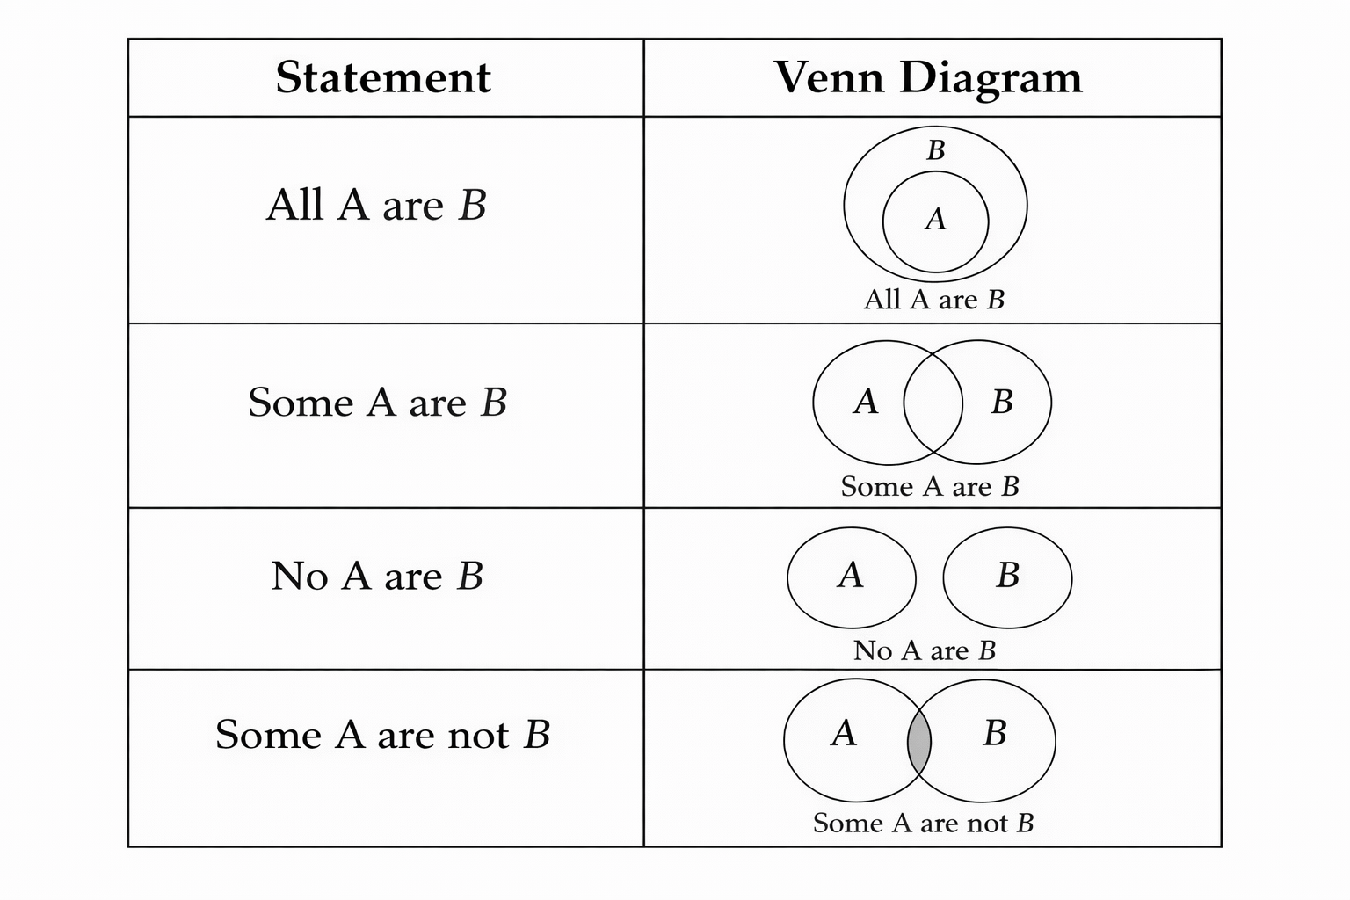
2. Check conclusions one by one
3. Do not assume anything extra
Solved Example:
Statements:
All soldiers are disciplined.
Some disciplined are officers.
Conclusion:
Some soldiers are officers.
Logic:
Not necessarily true (no direct link)
Answer:
Conclusion does not follow
Practice Questions (Syllogism):
Q4.
Statements:
All dogs are animals.
All animals are living beings.
Conclusions:
I. All dogs are living beings
II. Some animals are dogs
A. Only I follows
B. Only II follows
C. Both follow
D. Neither follows
Q5.
Statements:
Some books are pens.
All pens are papers.
Conclusions:
I. Some books are papers
II. All books are papers
A. Only I
B. Only II
C. Both
D. Neither

PART 4 – SERIES & MISCELLANEOUS

SSC REASONING – PART 4

8. SEATING ARRANGEMENT (Linear – Basic)
- Concept:
Seating arrangement questions test the ability to arrange persons according to given conditions. In SSC, seating arrangement questions are usually linear, simple and direct.
- Types Common in SSC:
• Persons sitting in a row
• Facing north or south
• Simple left–right or middle positions
- Method to Solve:
1. Fix the direction of the row first.
2. Place the sure information such as middle or end positions.
3. Use remaining conditions step-by-step.
4. Avoid jumping to conclusions early.

Solved Example:
- A, B, C, D and E are sitting in a row.
- C is in the middle.
- A is to the left of C.
- B is to the right of C.
- D is at one end.
- Logic:
There are five persons, so the middle position is third.
C occupies the middle.
A is placed to the left of C.
B is placed to the right of C.
One end is occupied by D, so the other end must be E.
Answer: E

Practice Questions (Seating Arrangement):
Q1. P, Q, R and S are sitting in a row facing north.
R is to the right of Q.
P is to the left of Q.
Who is sitting at the left end?
A. P B. Q C. R D. S
Q2. Five persons A, B, C, D and E are sitting in a row.
B is between A and C.
D is at one end.
E is to the right of C.
Who is sitting in the middle?
A. A B. B C. C D. E

9. LOGICAL STATEMENTS (Cause–Effect / Assertion Type)
- Concept:
Logical statement questions test the ability to understand cause–effect relationships or draw conclusions based strictly on the given statement.
- Common Question Types:
• Cause and effect
• Statement–Conclusion
• Course of action (basic)
- Method to Solve:
1. Read the statement carefully.
2. Identify the cause and the result.
3. Do not use outside knowledge.
4. Select the option that logically follows.

Solved Example:
Statement:
The government increased fuel prices.
Conclusion:
Transport cost may increase.
Logic:
Increase in fuel prices directly affects transport costs.
Answer: Conclusion follows.

Practice Questions (Logical Statements):
Q3. Statement:
Heavy rainfall has damaged crops in many areas.
Conclusion:
Food prices may rise.
A. Conclusion follows
- Conclusion does not follow
Q4. Statement:
Many students failed due to lack of preparation.
Conclusion:
Students should study regularly.
A. Conclusion follows
- B. Conclusion does not follow

Answer Key
Q1. A Q2. B Q3. A Q4. A

PART 5 – NON VERBAL & MIXED PRACTICE

10. NON-VERBAL REASONING
- Concept:
Non-verbal reasoning is based on figures, shapes, diagrams and visual patterns. It tests observation skills, visualisation ability and logical thinking rather than language or calculation.
- Nature of Non-Verbal Questions in SSC:
• Questions are simple and direct
• Mostly observation based
• No lengthy or confusing puzzles
• Easy scoring if basic rules are clear

Important Types Asked in SSC
- Figure Analogy
2. Figure Classification (Odd One Out)
3. Mirror Image
4. Rotation of Figures (90° or 180° only)

General Method to Solve Non-Verbal Questions
Step 1: Observe the basic shape of the figure.
Step 2: Count number of sides, corners, lines or dots.
Step 3: Check for symmetry, rotation or mirror image.
Step 4: Identify the pattern or rule.
Step 5: Eliminate incorrect options and select the correct one.

Solved Examples
Example 1 (Figure Analogy):
Triangle : Square :: Square : ?
Explanation:
Triangle has 3 sides.
Square has 4 sides.
The pattern shows an increase of one side.
Therefore, Square will change to a figure having 5 sides.
Answer: Pentagon

Example 2 (Mirror Image Concept):
In mirror image questions:
• Left side becomes right
• Right side becomes left
• Top and bottom positions remain unchanged
The option showing exact left-right reversal of the figure is the correct answer.

Practice Questions – Non-Verbal Reasoning
Q1. Which figure is the odd one out?
A. Triangle
B. Square
C. Circle
D. Rectangle
Q2. If a figure is rotated 90° clockwise, which option represents the correct position?
A. Option A
B. Option B
C. Option C
D. Option D
Q3. Which option shows the correct mirror image of the given figure?
A. Option A
B. Option B
C. Option C
D. Option D

11. MIXED REASONING PRACTICE (SSC LEVEL)
- Concept:
Mixed reasoning questions combine classification, coding-decoding, number logic and common-sense reasoning. These questions test overall logical clarity.
- Nature of Mixed Reasoning Questions in SSC:
• GUIDE and direct
• One-step logic based
• No confusing or misleading statements
• Easy to moderate difficulty

Practice Questions – Mixed Reasoning
Q4. Find the odd one out:
A. January
B. February
C. March
D. Sunday
Q5. Which word does not belong to the group?
A. Army
B. Navy
C. Air Force
D. Police
Q6. If BLUE is coded as the sum of alphabet positions (A = 1, B = 2 … Z = 26), find the code:
B = 2, L = 12, U = 21, E = 5
A. 38
B. 40
C. 42
D. 44
Q7. Find the missing number:
4 : 16 :: 5 : ?
A. 20
B. 25
C. 30
D. 35

Answer Key
Q1. Circle
Q2. Option showing correct 90° clockwise rotation
Q3. Correct mirror image option
Q4. Sunday
Q5. Police
Q6. 40
Q7. 25

